How to test My Beauty Organizer

1. Download Eclipse ID for Java developers 64 but or 32 bit depending on your machine from <https://eclipse.org/downloads/>
2. Download Oracle11g Express Database from choose the download based on your OS <http://www.oracle.com/technetwork/database/database-technologies/express-edition/downloads/index.html> Remember the username and password you used to when prompted because that Username/password combination is for the SYSTEM schema in the Oracle Database.
3. Go to Start | All Programs | Oracle 11g Express Edition | Get Started.
4. (Note: If you don’t see “Get Started” as one of the apps, go to the following location, which will take you to the Oracle Application Express using your browser: C:\oraclexe\app\oracle\product\11.2.0\server\Get_Started
5. Note: If you see the following error message:

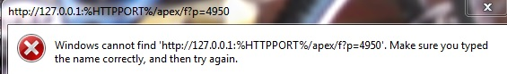

1. Go to the folder C:\oraclexe\app\oracle\product\11.2.0\server, and Right click GetStarted and select Properties. On the “Web Document” tab, replace “%HTTPPORT%” with 8080, So the URL becomes http://127.0.0.1:8080/apex/f?p=4950.)
2. You should see the following web page:

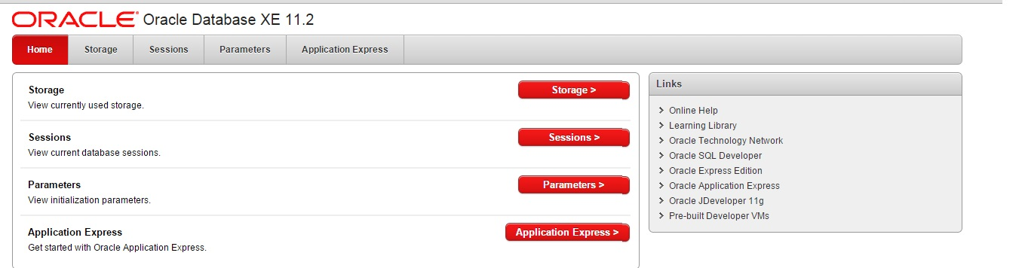

1. Select Application Express> button. Login using SYSTEM as the user, and admin as the password. You will see this web page:
2. 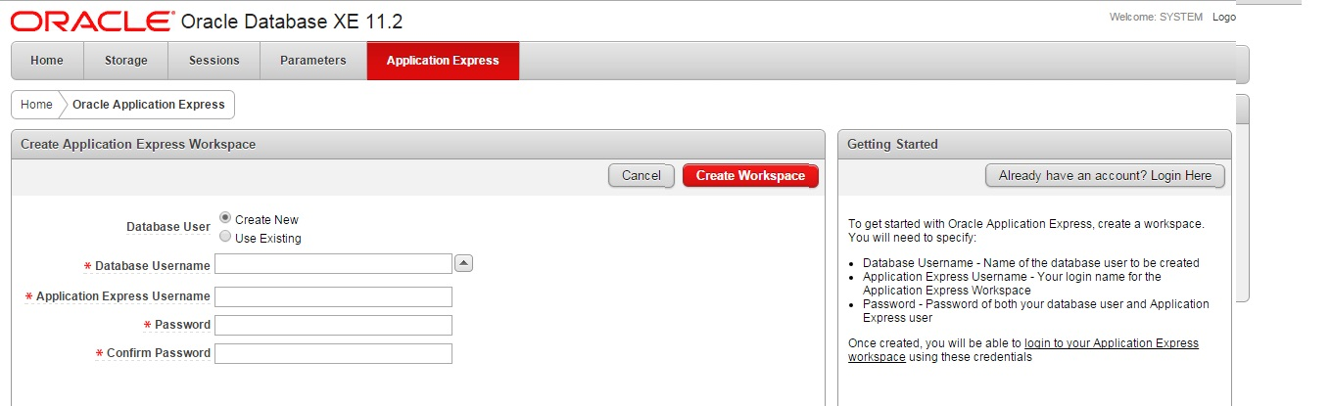
3. For Database User, select Create New. For Database Username and Application Express Username, DEVELOPER. Select developer as your password. Click Create Workspace. (you only have to create your workspace once.)
4. You should see “Successfully created workspace DEVELOPER. To begin click here to login.”
5. When you click and login, you will see the Application Express home page. Click SQL Workshop, then SQL Scripts
6. After that type these commands to create table that our application will use.
7. 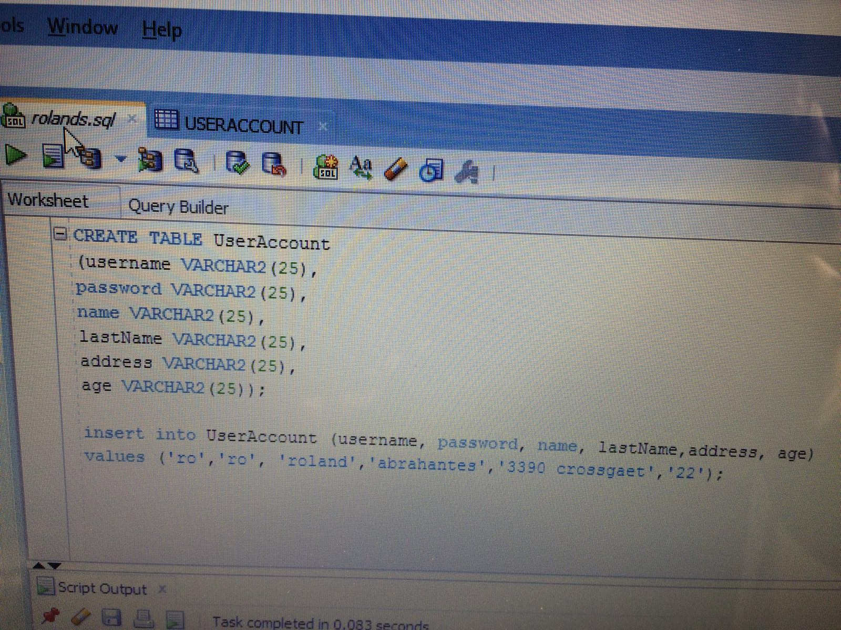
8. Confirm by clicking “Run Now”. (Ignore any errors concerning DROP statements. The DROP commands are included in case you must run the script more than once. If you ran the script a second time, you would not get the DROP errors.)